# Data Base

1. **ER diagram**

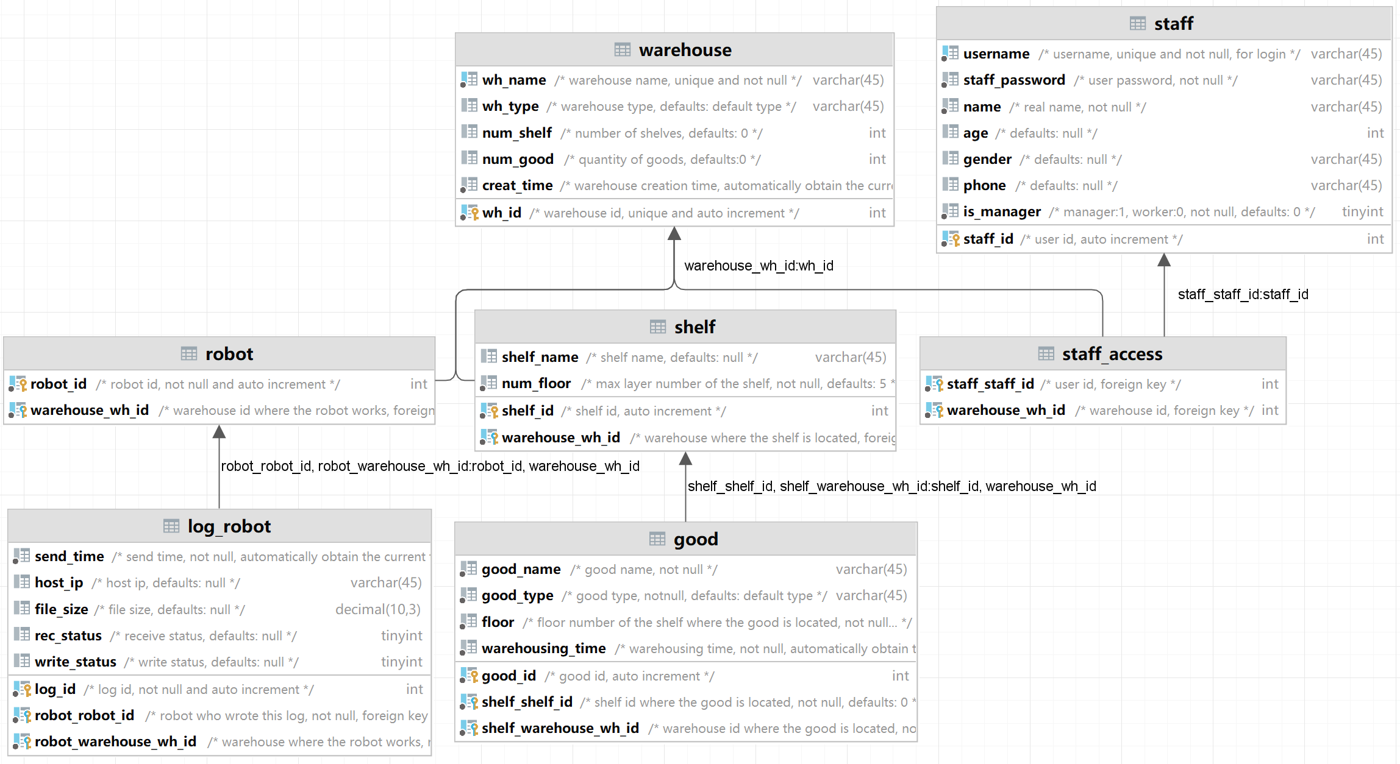

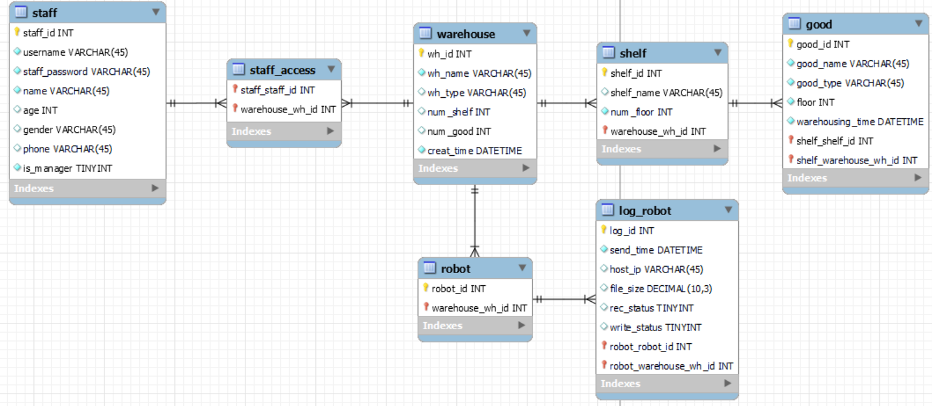

* 1. **Icon**
     1. Primary Key

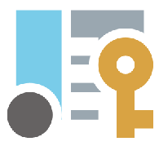

* + 1. Foreign Key & Primary Key



* 1. **Staff**

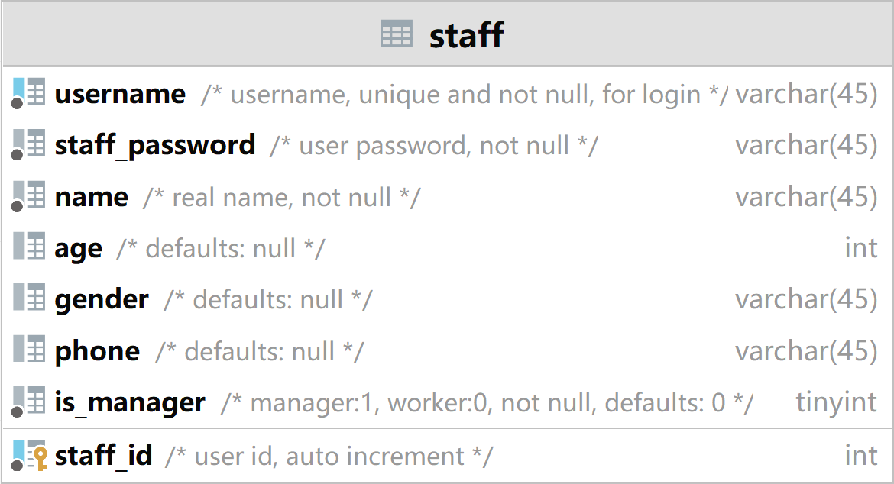

* + 1. This table is used to store the information of staff.
    2. Manager and worker are stored in the same table.
    3. Identity is distinguished by the attribute "is_manager".
  1. **Warehouse**

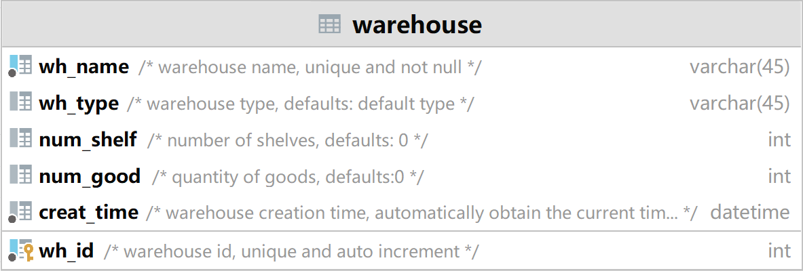

* + 1. It is used to store warehouse information.
    2. Including all kinds of attributes of each warehouse.
  1. **Staff Access**

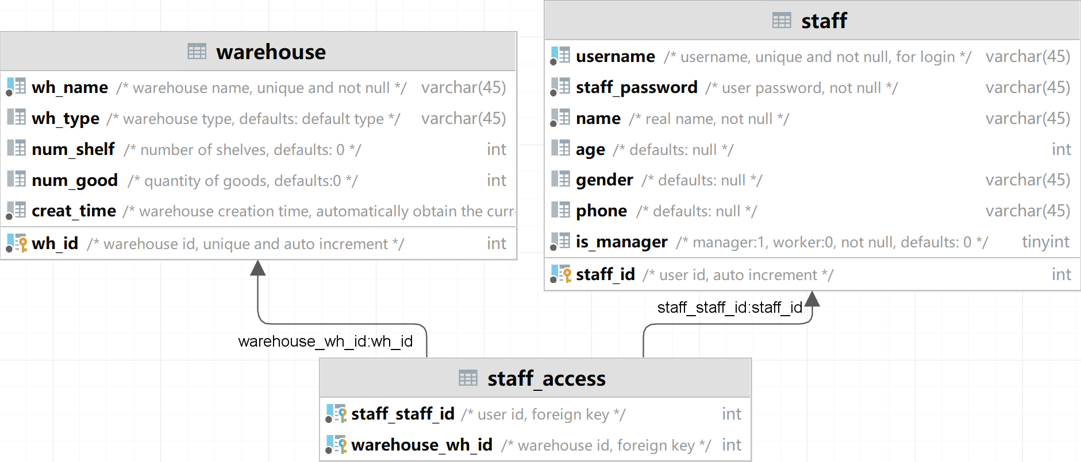

* + 1. Staff access records the permission of staff to the warehouse. The warehouse and staff are in a many-to-many relationship.
       1. For managers, only controlling warehouses with permissions is permitted. Managers can change the access permission of workers to the warehouse under control.
       2. For workers, only viewing warehouses with permissions is permitted.
  1. **Shelf**

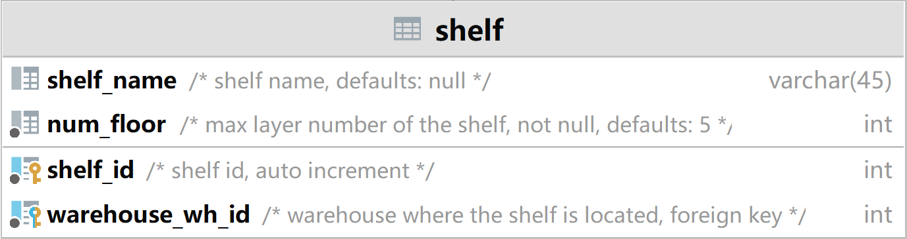

* + 1. Warehouse and shelf are in a one-to-many relationship.
  1. **Good**

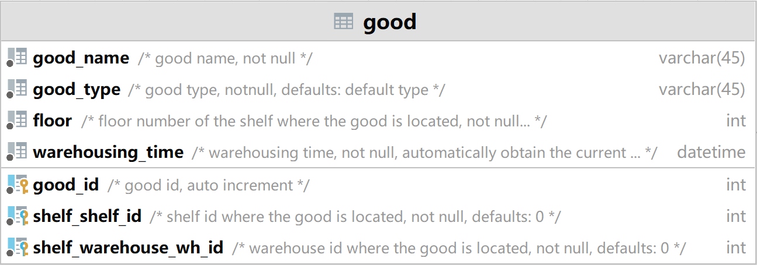

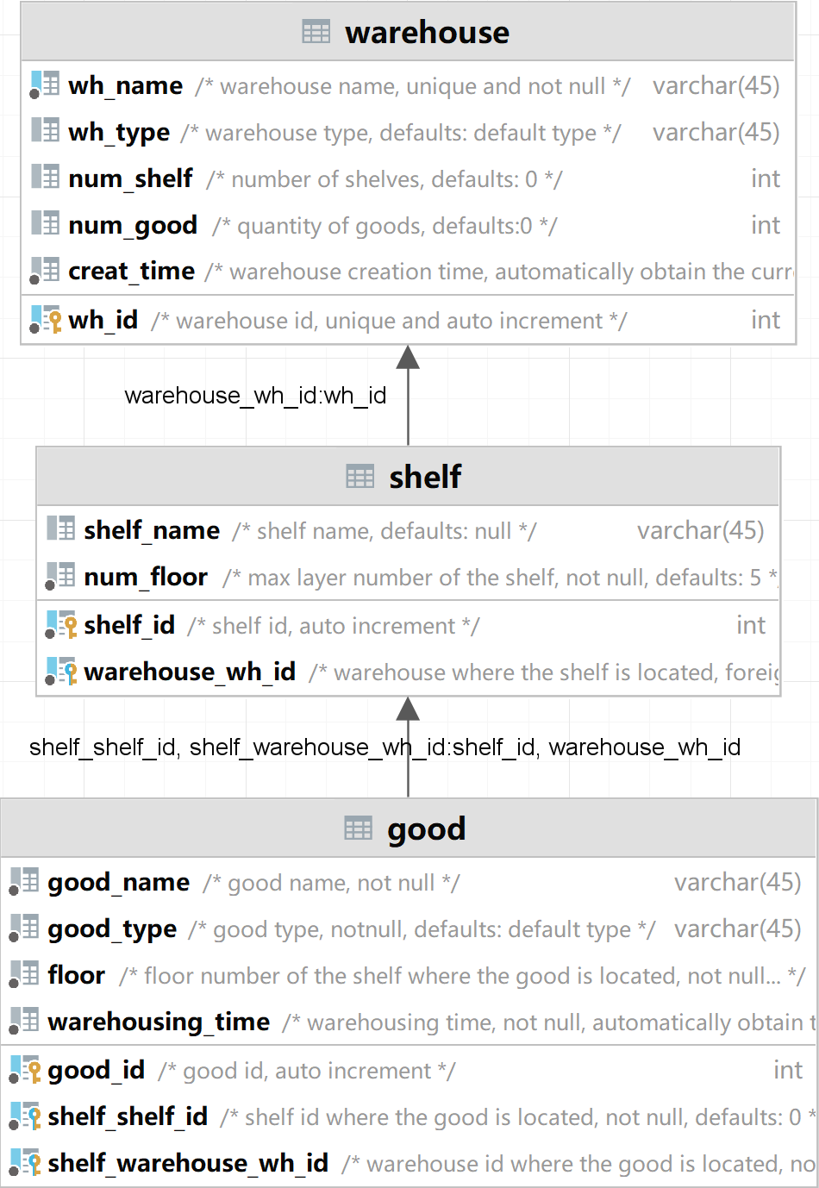

* + 1. Various information on the goods.
    2. "good_type" matches with the "wh_type" of the warehouse where the good is located.
    3. Shelf and good are in a one-to-many relationship.
  1. **Robot**

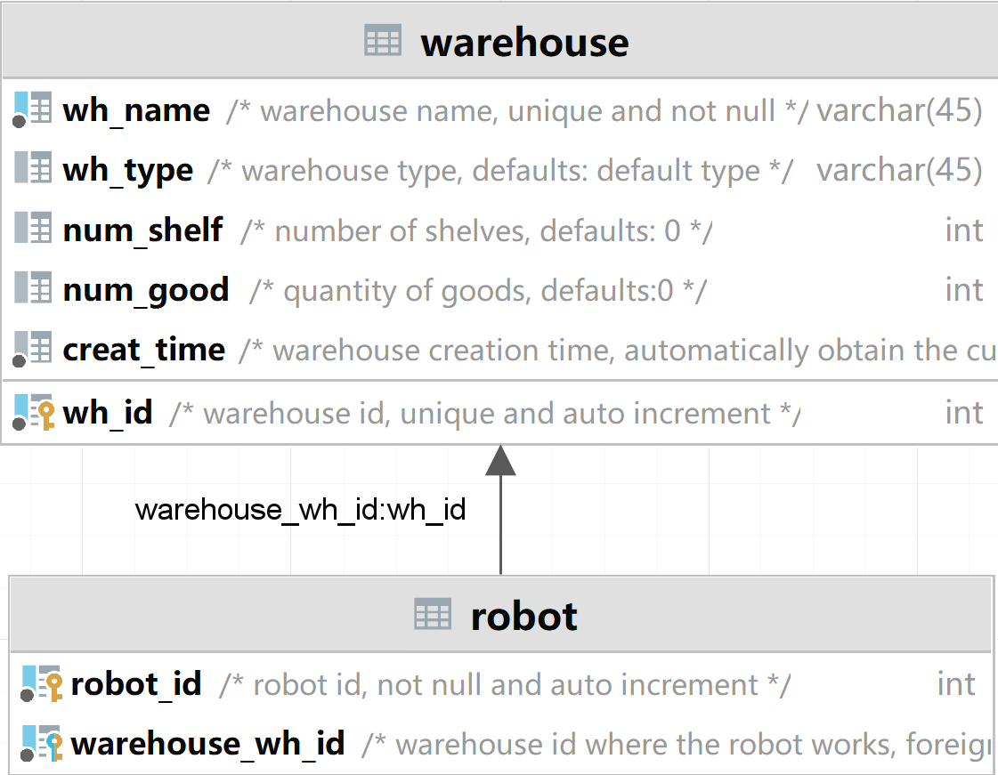

* + 1. Information with the robots.
    2. Warehouse and robot are in a one-to-many relationship.
  1. **Robot Log**

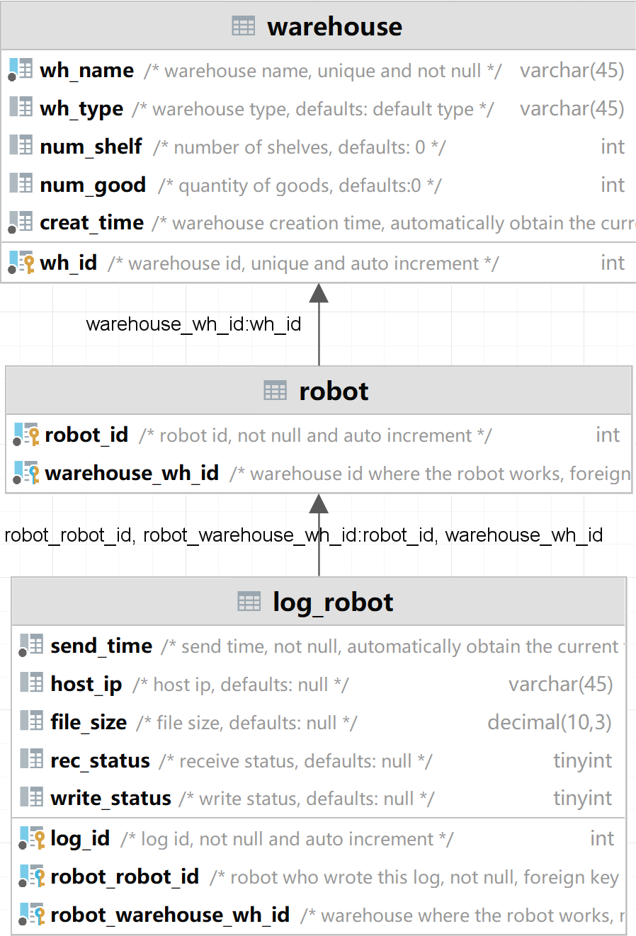

* + 1. This table records the robot log file.
    2. Robot and log are in a one-to-many relationship.